Theory 13 Programming the 16F688 to the MAN-74 LED Digital Display
The MAN-64 is a 7-segment digital display designed to produce all the Arabic numerals 0-9 and a few of the alphabetic characters, specifically A through F. The display is in a 14 pin package with a few pins missing to help us orient ourselves to the display. THE DISPLAYS ARE OUT OF PRODUCTION AND THEY ARE HARD TO COME BY. PLEASE TAKE REASONABLE CARE WITH THEM. IN PARTICULAR, NOTE THAT THERE IS A 220 ohm RESISTOR IN SERIES WITH ANY OF THE a-f DIODE ANODES (one resistor for EACH anode, 8 total resistors – 7 segments plus the decimal point.)
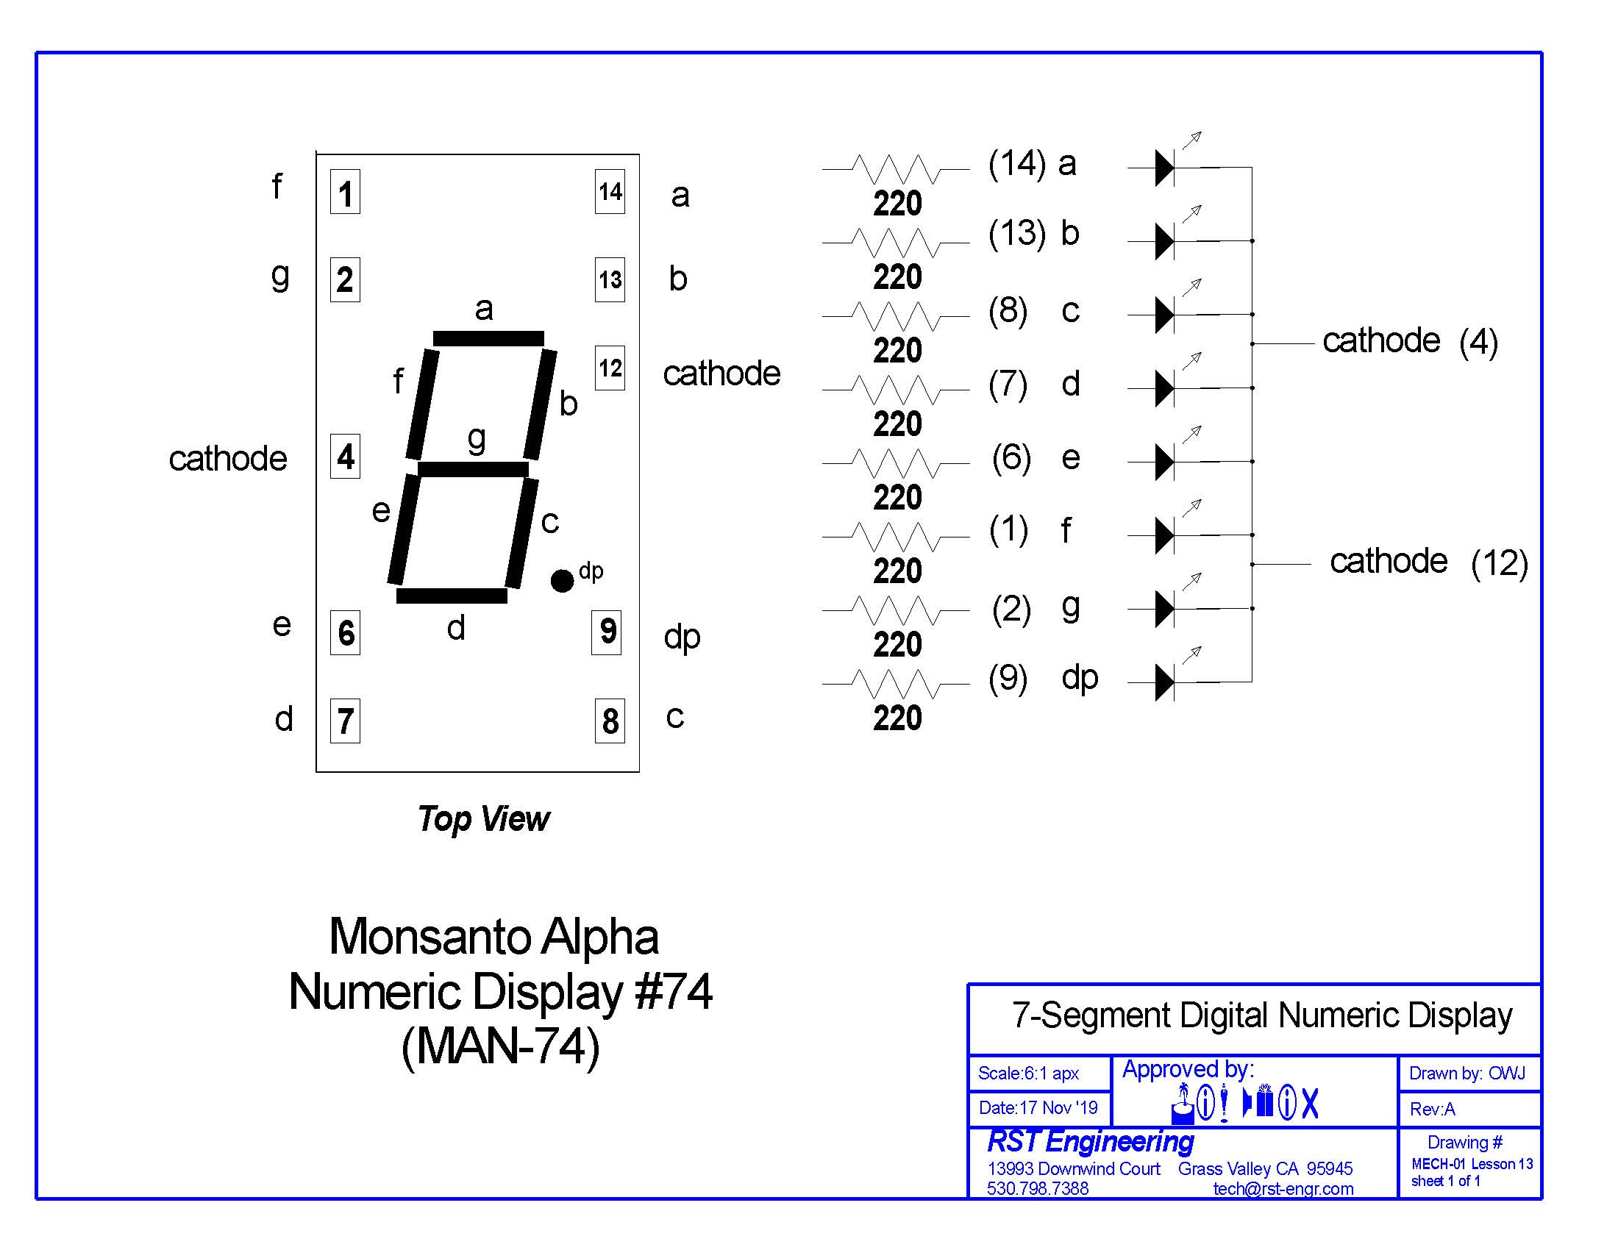

Each of the diode anodes will connect to a unique output pin on the 16F688 microcontroller as per the diagram below.
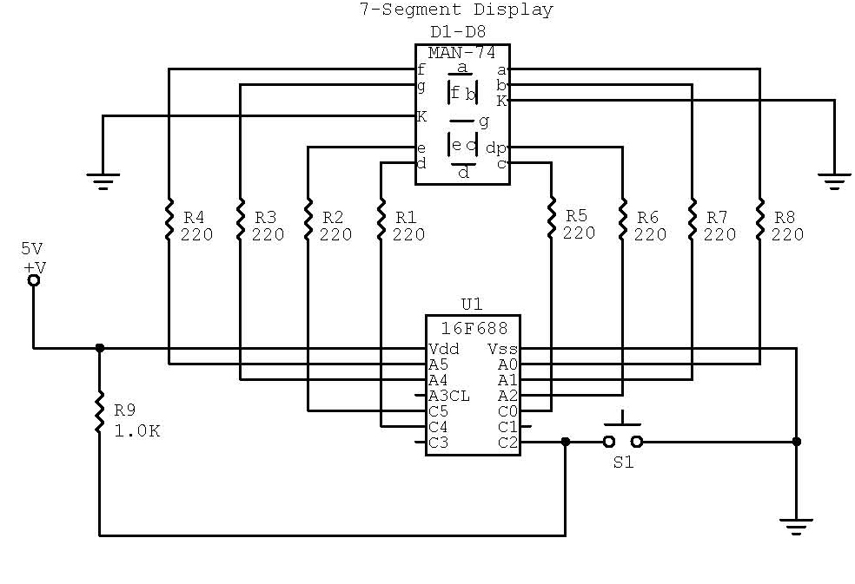

PLEASE PROCEED TO APPLICATION SECTION 1 NOW TO BEGIN CONSTRUCTION OF THIS CIRCUIT.
The program for “Betty1” is given below. This will be the ONLY cut-and-paste for this entire lesson. Everything else will be hand-entered by hand.

' Name : 7segjw-App13-betty1.bas
' Compiler : PICBASIC PRO Compiler 3.1
' Assembler : MPLAB X IPE v5.20
' Target PIC : 16F688
' Hardware : Lab Protoboard
' Oscillator : Internal 4 MHz.
' Keywords : 7 segment display
' Description : PICBASIC PRO program to light a 7-segment digital
' LED display.
'
' Definitions
' segment dp is Port A.2 Pin 11
' segment a is port A.0 pin 13
' segment b is port A.1 pin 8
' segment c is port C.0 pin 10
' segment d is port C.4 pin 6
' segment e is port C.5 pin 5
' segment f is port A.5 pin 2
' segment g is port A.4 pin 3
'
' number 0 is a,b,c,d,e,f
' number 1 is b.c
' number 2 is a,b,d,e,g
' number 3 is a,b,c,d,g
' number 4 is b,c,f,g
' number 5 is a,c,d,f,g
' number 6 is a,c,d,e,f,g
' number 7 is a,b,c
' number 8 is a,b,c,d,e,f,g
' number 9 is a,b,c,f,g
'
' letter b is c,d,e,f,g
' letter i is e,f
' letter t is a,e,f
' letter c is a,d,e,f
' letter h is b,c,e,f,g
' letter n is c,e,g
' letter g is a,b,c,d,f,g
' letter e is a,d,e,f,g
' letter y is b,c,f,g
'

#CONFIG

__config _INTRC_OSC_NOCLKOUT & _WDT_OFF & _MCLRE_OFF & _CP_OFF

#ENDCONFIG

CMCON0 = %00000111 ;sets A.0, A.1, and A.2 port bits to digital
ANSEL = %00000000 ;sets all ports to digital
TRISA = %00000000 ;sets all A ports to output
TRISC = %00000100 ;sets port C.2 to input, all the rest to output

DP var PORTA.2 ' Alias PORTA.2 to DP
SA var PORTA.0 ' Alias PORTA.0 to SA
SB var PORTA.1 ' Alias PORTA.1 to SB
SC var PORTC.0 ' Alias PORTC.0 to SC
SD var PORTC.4 ' Alias PORTC.4 to SD
SE var PORTC.5 ' Alias PORTC.5 to SE
SF var PORTA.5 ' Alias PORTA.5 to SF
SG var PORTA.4 ' Alias PORTA.4 to SG

IQ var byte ' Loop variable
NN var byte ' number variable

gosub portset

pushbutn:

IF PORTC.2 = 0 THEN ;Button is pushed
PAUSE 20 ;debounce sensitivity
IF PORTC.2 = 0 THEN ;Button is still pushed, debounced
GOTO mainloop ;Go to the main program
ENDIF
ENDIF
GOSUB betty
Pause 200
GOTO pushbutn

mainloop:

goto pushbutn

end

decpt:
FOR IQ = 1 to NN
High DP
Pause 500
Low DP
Pause 500
NEXT IQ
return

portset:

PORTC.0 = 0
PORTC.1 = 0
PORTC.3 = 0
PORTC.4 = 0
PORTC.5 = 0

PORTA.0 = 0
PORTA.1 = 0
PORTA.2 = 0
PORTA.4 = 0
PORTA.5 = 0
Return

betty:

HIGH SA
HIGH SB
HIGH SC
HIGH SD
HIGH SE
HIGH SF
HIGH SG
Pause 200
gosub portset
return

This program will go through the pushbutton routine pushbutn and then go to subroutine betty that will flash all 7 segments plus the decimal point. If it does NOT flash all the segments, stop NOW and find out why. It isn’t going to get any easier as we go along to troubleshoot.

Program BETTY2 simply lights each segment a through f one by one to see that each segment is driven by one and only one of the microcontroller ports and then goes back to pushbutn to let the user run through the program again.

Program BETTY3 lights all the digits 0-9 in sequence and then returns to pushbutn to ask if you want to see it again.

Program BETTY4 is what I would expect to see from you if you wanted those 25 extra points. You can make any word or series of words you like so long as you make at least 5 letters on your own. A through F is the suggested, but as you can see, I took it a step further and tried to make the program read what the pilots all called the little box that reminded them that there was something seriously wrong with the airplane.

*****************************************************

