Sierra College MECH-01
Jim Weir 530.272.2203
jweir@sierracollege.edu
www.rstengineering.com/sierra

Application 12

- Preparing the switch

- The first thing we have to do is to prepare a switch so that we can use it to control the 688. Notice that the switch has six sides. One side has a pushbutton. The opposite side is totally blank.
.
- The four small sides have terminals on two of the sides and nothing on the other small sides.

- Cut the two terminals off on one of the sides that have terminals.

- Solder small short wires to the remaining terminals on the remaining side.

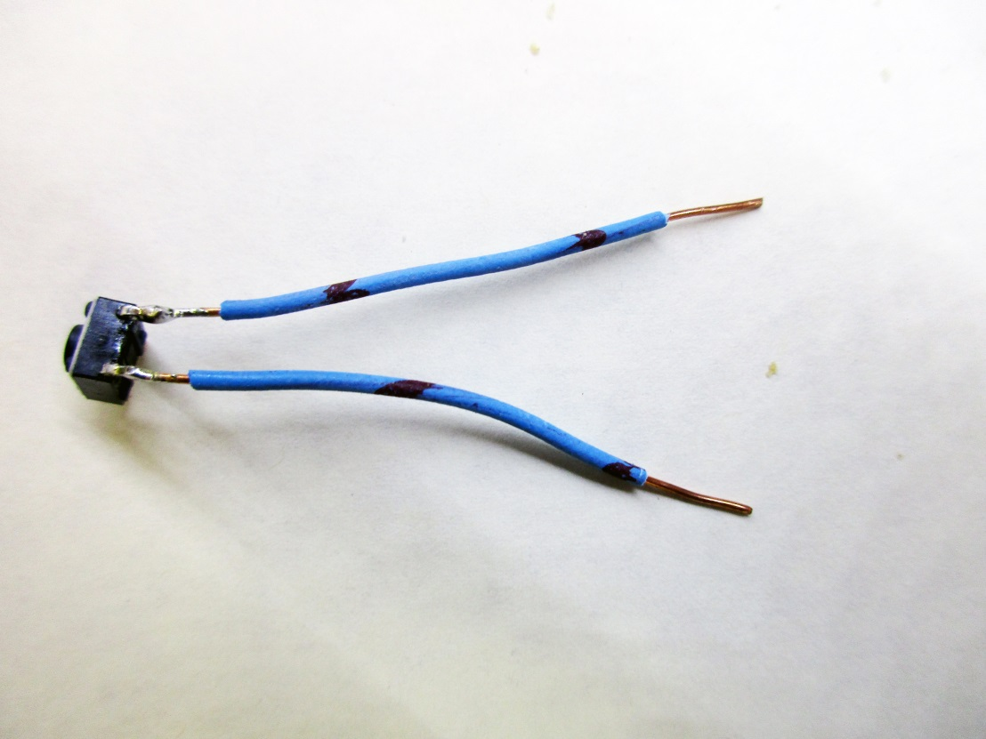

- Connect this switch, one lead to ground (0 volts) and one lead to pin 8 of the 688.

- Connect a 1k ohm resistor from pin 8 to +5
.
- Load hex file pushbutn.hex into your 688 at the instructor’s station.

- If you do NOT push the button, does BLINK come on?

- If you push the button, does BLINK come on and repeat forever?

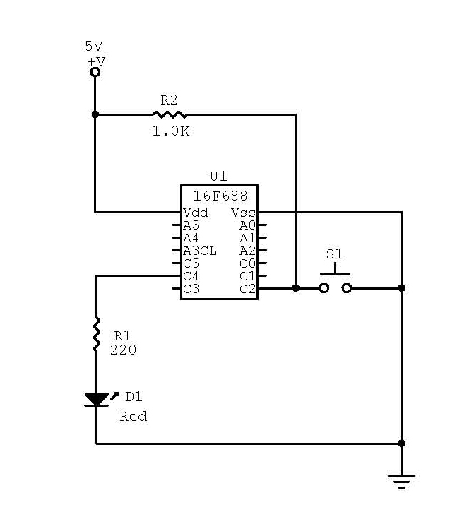

- Write and load program IFTHEN into your microprocessor.

- Does the switch control when the program loads and executes?

- Write and load program FORNEXT into your microprocessor

- Does the program execute 10 times and then return to no lights?

- Write and load program GOSUB into your microprocessor.

- Connect a 220 ohm resistor in series with an LED in accordance with the schematic below.

- Does the “nanny light” come on between pushbutton activation?

